02 #Подаци о Катедрама Одсека за ТМП (наставници и сарадници)
Chair
Chair of machines and apparatuses in wood processing
Head of chair
Prof. Dr. Gradimir Danon
The Chair of machines and apparatuses in wood processing was established on 29th August 2002. The Chair was composed of teachers, staff and laboratory technicians from the disbanded Chair of finished wood products design and the Chair of final wood processing. At the time of establishment the Chair consisted of five teachers and six associates: prof. Dr. Petar Todorović, full prof. Dr. Milutin Marjanov, full prof. Dr. Gradimir Danon.full prof., Dr. Dragan Lukačev, Assistant Professor, Dr. Aleksandar Dedić, assistant professor, MSc Nataša Atanackov teaching assistant, Mr. Zoran Đurišić, teaching assistant, Mira Mirić Milosavljević, assistant trainee, Vladislava Mihailović, assistant trainee, Dragan Jančevski, assistant trainee and Srđan Svrzić, assistant trainee.
At that time, the Chair members covered the following subjects: Technical Physics (first year of undergraduate studies), Engineering Mechanics (first year of undergraduate studies), Fundamentals of Mechanical Engineering (second year of undergraduate studies), Elements of regulatory techniques in wood processing (second year of undergraduate studies), Internal transport in wood processing (third year of undergraduate studies), and machinery and woodworking tools (third year of undergraduate studies).
Two laboratory technicians, Mihajlo Bogdanović (Technical Physics and Elements of regulatory techniques in wood processing) and Milan Vujković (Internal transport in wood processing) were the Chair members at the time of its establishment.
At the constitutive session, the first elected Head of the Chair was Dr. Gradimir Danon full professor. The elected Deputy Head of the Chair was Dr. Petar Todorović, full professor and the elected Secretary Srđan Svrzić assistant trainee. After the expiry of the two-year mandate the elected Head of the Chair was Dr. Petar Todorović, full professor, his deputy was Dr. Gradimir Danon, full prof., and secretary Goran Milutinović, Grad. mechanical engineer. They remained at these functions until October 2010. After the retirement of prof. Dr. Petar Todorovic (30th June 2010), the reelected Head of the Chair was (once again) Dr. Gradimir Danon full prof., Deputy Head of the Chair is Dr. Srđan Svrzić, Assistant Professor and the Secretary Marija Mandić, teaching assistant.
Changes in the composition and staff of the Chair from 2002 to 2016
2002- Dragan Jančevski, teaching assistant in the subject Internal transport left the Faculty of Forestry.
2003- Mladen Furtula was admitted to the Chair at the position of assistant trainee for the scientific field machines and apparatuses in wood processing.
2004- Goran Milutinović, Grad. Mechanical Eng. was admitted to the Chair as the laboratory technician in the Laboratory for machines and tools.
In 2006, the elected assistant professor for the narrow scientific field Machines and apparatuses in wood processing was Dr. Nataša Atanackov.
In 2007, (on 30th September) Dr. Milutin Marjanov, full. prof. and a member of the Chair since its establishment retired after a two-year extension.
In 2008 (on 5th October), MSc Zoran Đurišić, teaching assistant and a member of the Chair since its establishment passed away. That same year Dr. Nataša Atanackov, assistant professor, left the Chair.
In 2009 Marija Mandić was admitted to the Chair at the position teaching assistant for the scientific field Machines and apparatuses in wood processing. That same year Aleksandra Svrzić was admitted to the Chair as a laboratory technician for the subjects Technical Physics and Elements of regulatory techniques in wood industry.
In 2010 (30th September) Dr. Petar Todorovic, full. prof., the founder and long-time Head of the Chair retired.
In 2010 Milan Vujković, laboratory technician for the subject Internal transport, and the Chair member since its establishment retired. He died in 2011.
In 2015 Dr. Marija Mandić and Dr. Mladen Furtula were elected assistant professors for the narrow scientific field Machines and apparatuses in wood processing (12th May, 2015).

Chair members (1st January, 2017)
- Dr. Gradimir Danon, full professor, Head of Chair
- Dr. Aleksandar Dedić, associate professor
- Dr. Marija Mandić, assistant professor, Chair Secretary
- Dr. Mladen Furtula, assistant professor
- Dr. Srđan Svrzić, assistant professor
- Dr. Mira Mirić-Milosavljević, professional associate
- Dr. Vladislava Mihailović, professional associate
- Dr. Dragan Lukačev, professional associate
- MЅc Goran Milutinović, laboratory technician
- Aleksandra Svrzić, laboratory technician
Chair subjects
Undergraduate subjects
Compulsory subjects
Technical physic
Technical mechanics
Automation of furniture and wood products production
Mechanical engineering with industrial energetics
Internal transport
Machines and tools in wood processing
Elective subject
Safety at work
Applied electrotechnics in wood industry
Wood industry energetics
Pneumatics and hydraulics in wood industry

Master studies
Systems of automatic management in wood processing
Interaction of processed and tool material in wood processing
Wood processing machines with computerized numeric control
Unconventional wood processing techniques

Doctoral studies
Scientific and research work methodology
Machines and tools in wood processing
Wood industry energetics
Automatic management systems in wood processing
Transport and storage of solid material in wood industry
Dynamic modeling of the process of furniture and wood products production
Vibro-acoustic diagnostics of systems and processes
Selected student papers / final papers/ master papers / dissertations/ field training
Doctoral dissertations:
„Analiza obradljivosti hrastovine pri obimnom glodanju”, Marija Mandić (2015); “Uticaj ekoloških i energetskih faktora na korišćenje čvrstih drvnih goriva u Srbiji”, Mladen Furtula (2014); „Zenerov model viskoelastičnosti za ortotropno čvrsto telo i njegova primena u mehanici drveta”, Mira Mirić Milosavljević (2012); „Stabilnost veštačkog sušenja drveta za izabrane režime”, Srđan Svrzić (2010).
Маster of Science theses: „Uticaj jonizujućeg zračenja na svojstva nekih kompozita na bazi drveta”, Srđan Svrzić (2004.).
Master papers: „Uticaj zatupljenosti alata na snagu rezanja pri obradi drveta obimnim glodanjem”, Miloš Bižić (2016); „Procena uticaja tehnoloških parametara na gubitak mase i širinu propiljka kod rezanja hrastovine vodenim mlazom sa abrazivom”, Velimir Đukuć-Lazović (2015); „Merenje sile rezanja kod tehnološke operacije rendisanja”, Miloš Karavdija (2015); „Gubitak mase materijala kod obrade vodenim mlazom”, Lazar Janković (2013); „Uticaj nekih fizičkih i mehaničkih svojstava na specifični otpor rezanja hrastovine”, Bojan Crnogaća (2013); „Specifični otpori rezanja pri obradi bukovine obimnim glodanjem”, Milkica Milutinović (2013); „Istraživanje uticajnih faktora na specifični otpor rezanja nekih tipova ploča na bazi drveta”, Goran S. Milutinović (2012); Specifičnosti CNC mašina za obradu drveta i njihovo programiranje”, Dragana Kolarević (2012).
Final papers ‒ undergraduate studies: „Analiza i predlog transportnog sistema u odeljenju za mašinsku obradu masiva ‘TINA’ A.D. Knjaževac”, Milanović Milan (2016); „Upotreba ultra-zvuka kao pokazatelja stanja drveta”, Duško Nunić (2016); „Gubitak mase materijala kod obrade vodenim mlazom”, Ivana Lazić (2016); „Analiza i predlog transportnog sistema u odeljenju za mašinsku obradu masiva TINA A.D. Knjaževac”, Milan Milanović (2016); „Unutrašnji transport u fleksibilnim proizvodnim sistemima”, Tamara Janićijević (2016); „Skladišta i transportni uređaji u preradi drveta”, Jelena Mladenović (2016); „Zaštita od požara u pneumatskim instalacijama u drvnoj industriji”, Čapaković Vladan, 2015; „Energetski bilans pilanske prerade u preduzeću ‘Maja’”, Pejović S. Maja (2015); „Postojeće stanje unutrašnjeg transporta u firmi ‘Drvoteks’”, Planojević Darko (2015); „Kogeneracija i mogućnost njene primene u pilanskoj preradi drveta”, Ziriković M. Milomir (2015).
Final papers ‒ vocational studies: „Mogućnost unapređenja pneumatske instalacije u firmi Dipo”, Jelena M. Kaplarević (2016); „Mogućnosti zamene fosilnih goriva čvrstim drvnim gorivima u turističkim objektima – primer: Nebeske stolice, Sunčani vrhovi i Grand Kopaonik”, Kovečević Dušan (2015).
Research / Projects
- Innovation project I.5.1365: “Valorization of forest and wood industry residues through chemical products and energy”, Ministry of Science and Technology of RS, Faculty of Forestry, Belgrade, the 1996‒1997 period. Project leader: Dr. Gradimir Danon.

- Scientific and research project 173A: "Improvement of the management of exploitation and maintenance of tires in organized fleets", Ministry of Science and Technology of the Republic of Serbia, Faculty of Forestry, Belgrade, Faculty of Mechanical Engineering in Belgrade, 2002-2003. Project leader: Dr. Gradimir Danon.

- Scientific and research project TD 7052A: "Resource management in the city transport company", Ministry of Science and Technology of the Republic of Serbia, Faculty of Forestry, Belgrade, Belgrade Faculty of Mechanical Engineering, Traffic Engineering, Belgrade, Faculty of Organizational Sciences, Belgrade, 2005-2007. Project leader: Dr. Gradimir Danon.

- "Feasibility Study for the commercial use of wood waste as a resource for economic development in the north of Montenegro," Faculty of Forestry in Belgrade, the contracting authority FORS Montenegro, CHF International, the United States Agency for International Development (USAID), August 2007. Project leader: Dr. Gradimir Danon.

- Scientific and research project TR20070 "Wood biomass as a resource for sustainable development of Serbia", the Ministry of Education, Science and Technological Development of the Republic of Serbia, 2008-2010. Project leader: Dr. Gradimir Danon.
Centers/ Laboratories
1.Laboratory for Technical Physics and Regulation technics

The laboratory was established in 1960. It has 20 working places for exercises. It is used for practical exercises for students of the Department of technologies, management and design of furniture and wood products for the following subjects: Technical Physics, Applied electrical engineering in timber industry and Automation in the production of furniture and wood products. Measurements and tests in the following areas can be performed in the Laboratory: measurement of time-variable electrical quantities and sizes that can be converted into electrical measures, contactless measurement of dimensions with the possibility of a linear increase of over 100 times, detection of active faults in the material, measuring of the volume levels (testing the effects of noise).
2. Center for machines and tools for wood processing
The center for machines and tools for wood was formed on 21st July, 2007 from the Laboratory and workshop for wood processing machines, which had been formed much earlier (1970).
The head of the Center is prof. Dr. Gradimir Danon. The center is the result of accumulated knowledge in the field of machine constructions, development of products and processes in wood industry, and is qualified for different areas of research. The Centre's activities cover the following areas:
• Education and training of students,
• Scientific research,
• Prototyping of furniture and wood products.
The Center helps in the implementation of educational and scientific programs with an emphasis on student training for the application of the acquired knowledge (undergraduate, master and doctoral studies), as well as the solving of practical problems in timber industry companies. The Centre conducted experiments for a doctoral thesis (of Dr. Marija Mandic), a Master of Science thesis ( of MSc Zoran Đurišić), ten master papers and more than twenty graduate papers at the undergraduate level.

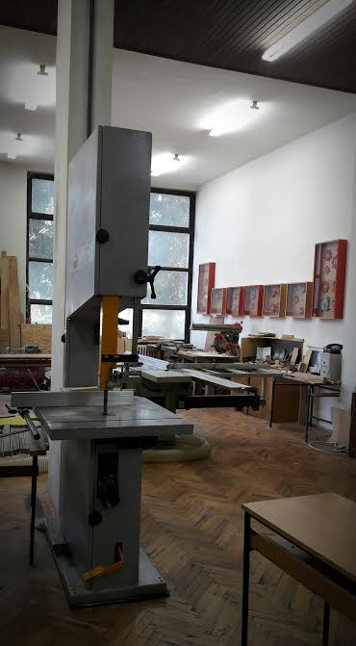Center for machines and tools in wood processing
The center has the following laboratory machines for mechanical processing of wood and wood-based materials: combined wood processing machine (planing, milling machine, saw and drill), grinding machine, band saw and a lathe. The Center owns a comprehensive collection of tools for primary and final wood processing.
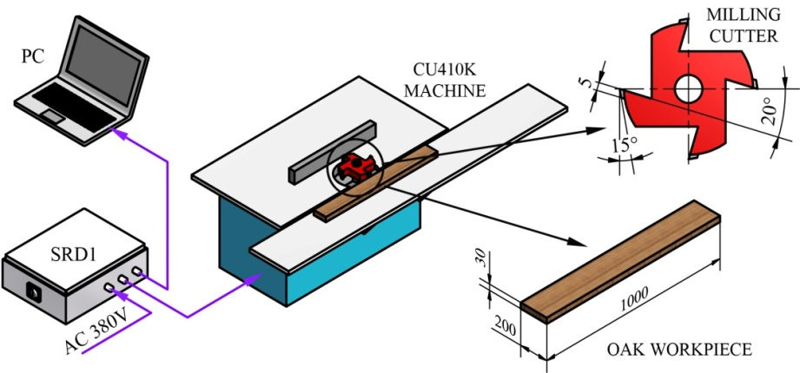 Installation for sawing strength measurement Srd 1
For the purposes of scientific research the Center has two measurement and data acquisition devices - SRD1 and SRD2 for measuring sawing strength in the mechanical processing of wood and wood-based materials, non-contact speed encoder, contactless temperatures encoder (up to 700 ° C), a microscope with up to 500x magnification and other small equipment.

3. The Centre for Biomass
The Centre for Biomass was established by the University Council in Belgrade on 16th February, 2007. The Faculty elected Dr. Vojislav Bajić full prof., as the Head of the Center and his elected deputy was Dr. Gradimir Danon, full prof. The Rules of Procedure of the Centre for Biomass was also adopted (2011) and following the retirement of prof. Dr. Vojislav Bajić, prof. Dr. Gradimir Danon was elected the Head of the Center.
The following activities were intended by the Rules of Procedure:
- Development and maintenance of a database of wood biomass (wood residues in forests and wood waste in wood processing industry)
- Monitoring and implementation of the latest achievements in the use of wood biomass.
- Activity in the collection, acquisition, development and dissemination of knowledge on renewable energy sources;
- Linking and establishment of cooperation with similar institutions in the country and abroad dealing with similar issues.
- The popularization of the use of wood biomass.
- Monitoring and initiating legislation in the field of biomass.
- Coordination of the provision of financial resources from local and foreign stimulation funds or interested investors for the realization of projects in the field of biomass utilization.
- Development of studies and programs in the field of the use of biomass for energy.
- Establishment of a laboratory for research in the field of biomass
- Issuance of newsletters and magazines, popular brochures and books and electronic editions of papers on the use of wood biomass.
- Analysis and proposals for improving the legal and institutional framework in the use of wood biomass.
- Functional integration of educational and research activities in the field of biomass.

So far, the Center has no space or equipment.

